# File permissions in Linux

## Project description

This project involves creating a robust file permission management system using Linux commands. Utilizing commands such as ls -l, ls -a, ls -la, chmod, the system will display and allow users to set and modify file permissions for various user groups, including owners, groups, and others.

## Check file and directory details

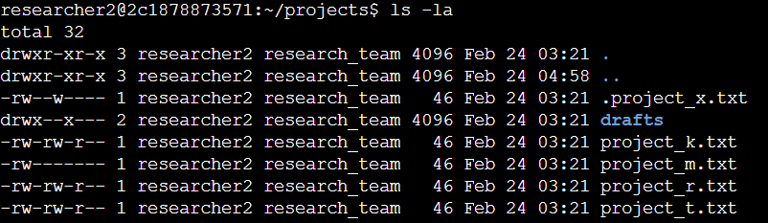

This document displays the file structure of the /home/researcher2/projects directory

and the permissions of the files and subdirectory it contains.

1. Firstly, I entered into the projects directory using the cd command.
2. Next, I used ls -l command to display the permissions to files and directories.
3. And then I utilized the ls -a command to display the hidden files.
4. Finally, I combined steps 2 and 3 to display the permissions to files and directories including hidden files using ls -la command.

## Describe the permissions string

In the /home/researcher2/projects directory, there are many files with the names and permissions:

For example, we can take a file from the above output (i.e) project_k.txt, it shows the output -rw-rw-r- - as permission for the project_k.txt.

* The first character ‘-’ denotes a regular file.
* The next three characters ‘rw-’ represent the read, write operation and lack of execution operation given to the user (i.e. owner) of the file.
* The next three characters ‘rw-’ also represent the read, write operations and lack of execution operation given to the group (i.e. larger group that the owner is a part of) of the file.
* The last three characters ‘r- -’ denotes that the other owner type (i.e. all other users on the system) has read permissions and lacks write and execute permissions

## Change file permissions

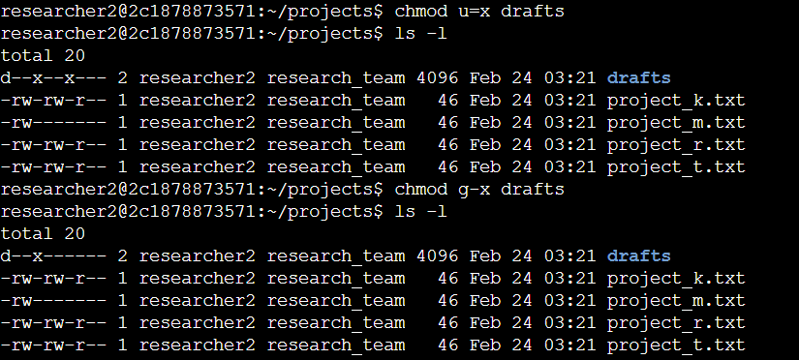

In the output, I used the commands ls -l and chmod to change the file permissions.

* First ls -l command is used to display permissions to files and directories
* To change the permissions chmod command is used to make changes in the permission by following the least privilege option.
* In the first chmod command the owner of the file (i.e. user) is given permission for execution operation.
* Second chmod command is used to remove the execution operation permission from the group.
* Atlast, the ls -l command is used to verify that permission is granted or disabled from particular owners in the linux.

## Change file permissions on a hidden file

In the output, if a hidden file has incorrect permissions so as to change the permissions as needed. This action will further remove unauthorized access and strengthen security on the system.

* The ls -la command is used to display the permissions of the hidden file.
* In that the user and group owner types have incorrect write permissions.
* To change the permission of the file, I used the chmod with specified arguments so that both the user and the group can read, but not to write the file.
* For achieving the target, the chmod is used with “u-w, g-w, g+r” along with the desired file name.
* Then ls -la command is used to cross check the permissions of the hidden files.

## Change directory permissions

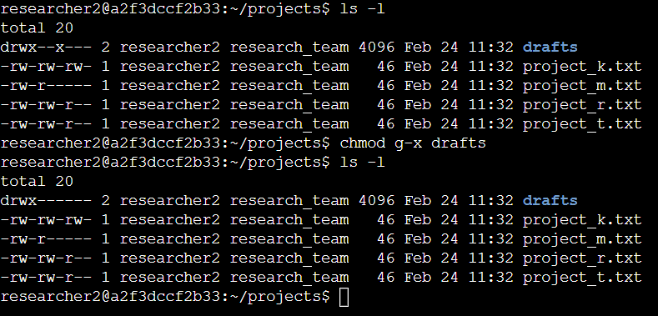

In this task, I changed the permissions of a directory. First, to check the group permissions of the /home/researcher2/projects/drafts directory and then to modify the permissions as required.

1. In the output, first I used ls -l command to check the permissions of the drafts directory.
2. Next, to remove the execute permission for the group from the drafts directory. So I utilized the chmod command to change the permissions.
3. In that, both the user and the group can read, but not write to the file. For this I removed the execution permission from the group by “chmod g-x drafts” command.

## Summary

The project aims to enhance security by ensuring precise control over who can read, write, or execute files, thereby safeguarding sensitive data and system integrity in a Linux environment.The chmod command is crucial for changing file permissions, allowing users to specify read, write, and execute permissions for the owner, group, and others. Additionally, it will include documentation for users to easily understand and implement file permission configurations.